**1.What is the purpose of the core module in AEM?**

Ans- The core module in an AEM project contains **backend logic**,

**2.What kind of files and code can be found in the core folder?**

Ans-The core folder contains: filters,listeners,models,schedulers,servlets,pom.xml.

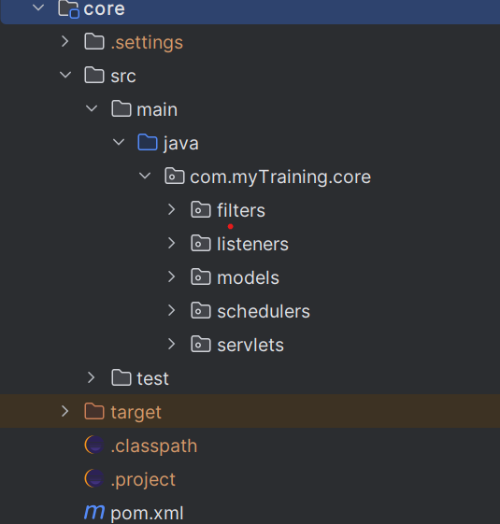

**3.Explain the role of ui.apps in AEM projects.**

Ans- It contains front-end resources.

**4.How are components structured in the ui.apps folder?**

Ans- **ui.apps/src/main/content/jcr_root/apps/myTraining/components**

**5.Hello World Component:**

* Where is the Hello World component located in both core and ui.apps?

a)Hello World Component in core is located in:

**core/src/main/java/com.myTraing.core/models/HelloWorldModel**

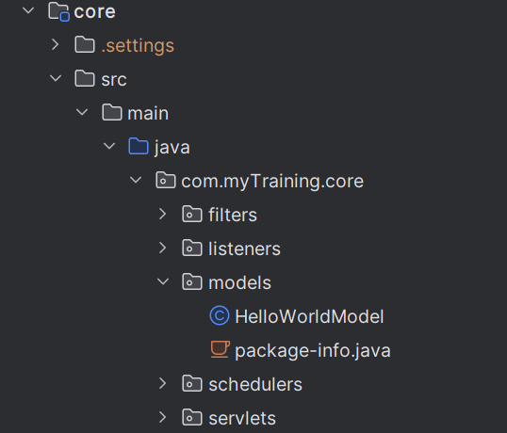

b)Hello World Component in ui.apps is located in:

**ui.apps/src/main/content/jcr_root/apps/myTraining/components/helloworld**

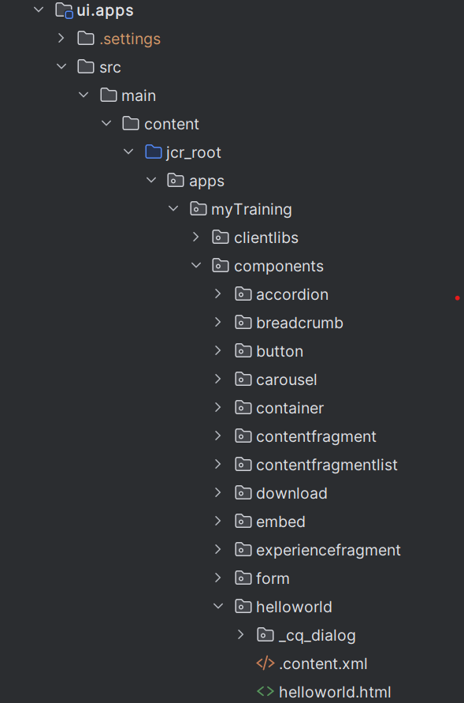

* Explain the Java class (in core) for the Hello World component.

Ans- This Java model provides backend data to the HTL file.

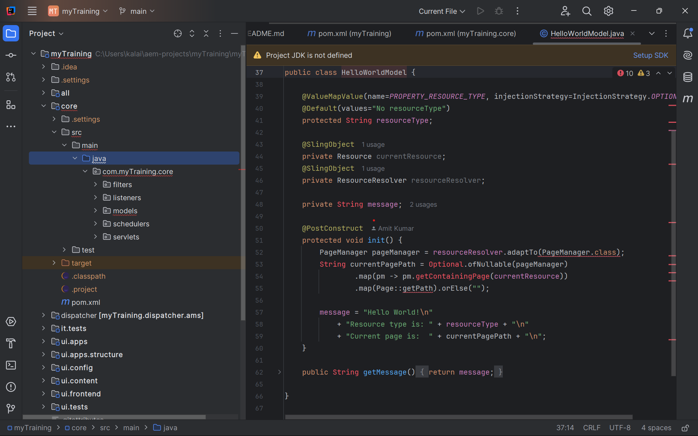

* How does the HTL script work in ui.apps for Hello World?

Ans- It retrieves the message from HelloWorldModel.java and displays it.

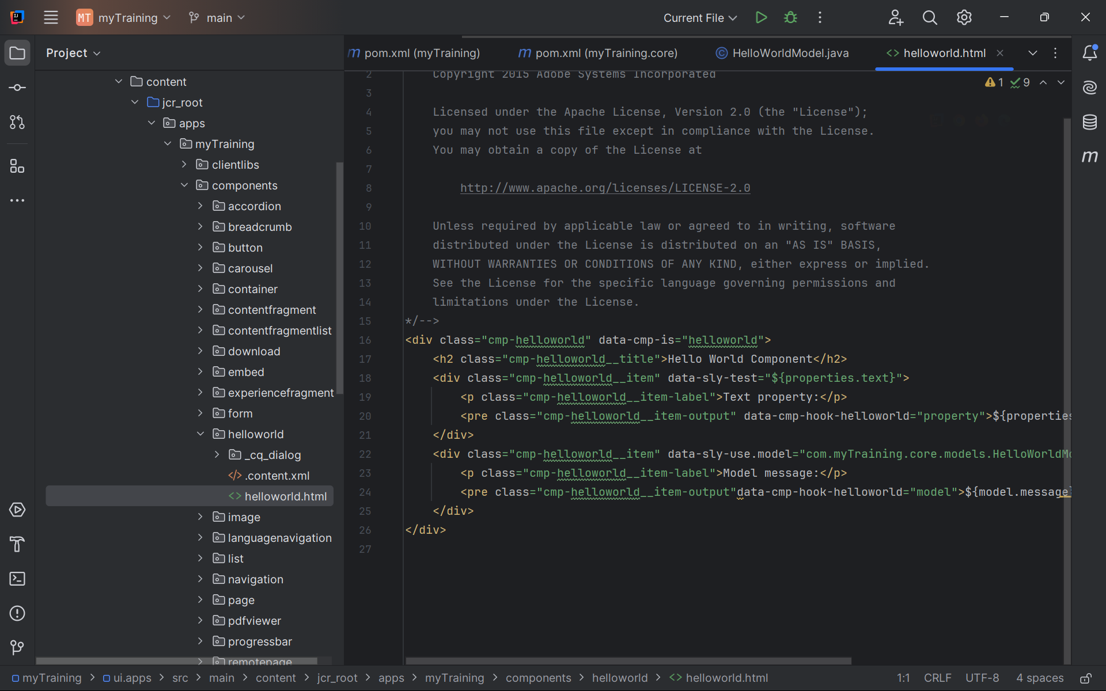

* How are properties and dialogs defined for this component?

Ans-Properties are stored in content.xml while dialoges are stored under _cq_dialog

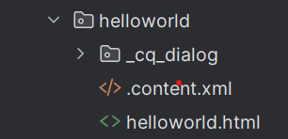

**6.What are the different types of AEM modules (core, ui.apps, ui.content, etc.)?**

Ans-all,core,ui.apps,ui.config,ui.content..etc.,

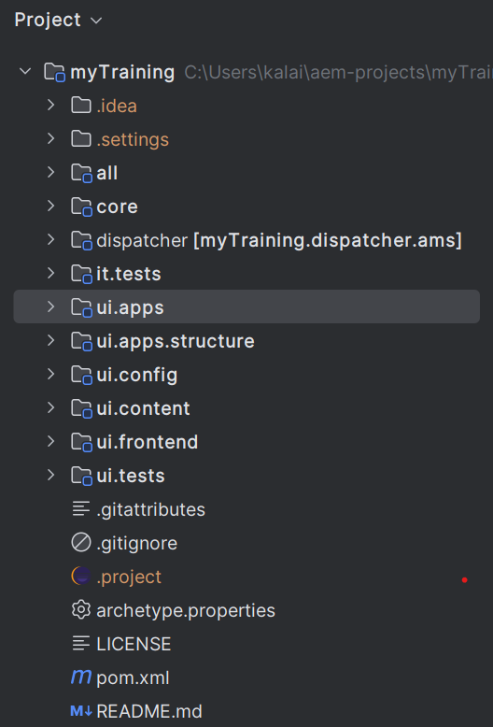

**7.How does Maven build these modules?**

Ans- Maven builds each module based on its POM files (pom.xml).Each module has its own pom.xml.

**8.Explain the build lifecycle of Maven in the context of AEM.**

Ans- Clean - Validate - Compile - Test - Package - Install - Deploy

**9.How are dependencies managed in pom.xml?**

Ans-Maven manages dependencies using the <dependencies> section in pom.xml

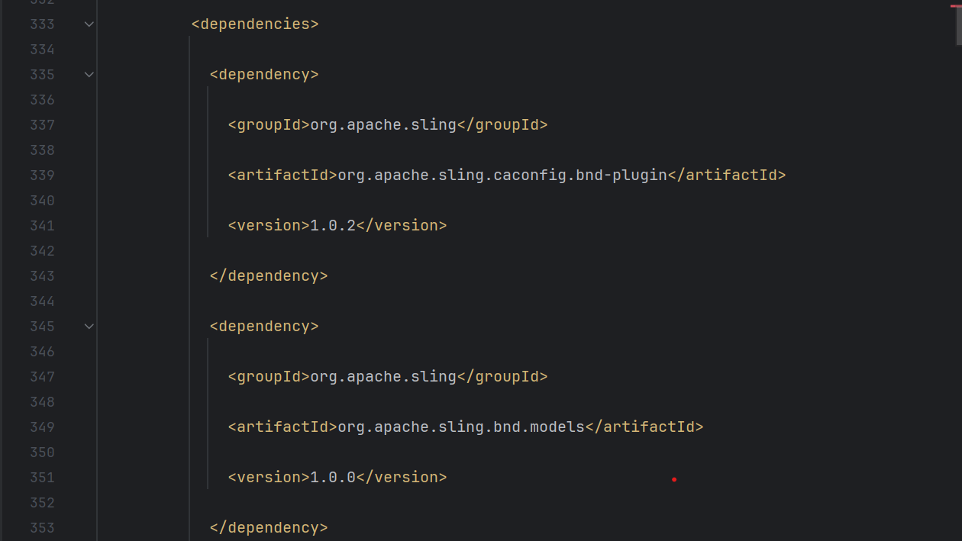

**10.Why is Maven used instead of other build tools?**

* **Automated Dependency Management**
* **Modular Build Process**
* **Standardized Project Structure**
* **Integration with AEM Cloud SDK**

**11.What advantages does Maven offer for AEM development?**

Ans-Dependency Management, Seamless Integration with AEM

**12.How does Maven help in managing dependencies and plugins in AEM projects?**

Ans-Dependencies are defined in pom.xml. Plugins are used to deploy content and bundles to AEM.

**13.What does mvn clean install do in an AEM project?**

Ans- mvn clean install Cleans, builds, and installs the project

**14.How to deploy packages directly to AEM using Maven commands?**

Ans- mvn clean install -PautoInstallPackage

**15.Explain the purpose of different Maven profiles in AEM (autoInstallPackage, autoInstallBundle).**

Ans-

**autoInstallPackage**: Uploads everything (code, components, and content) to AEM.

**autoInstallBundle**: Uploads only the backend Java code (OSGi bundle) without affecting content.

**16.What is the purpose of dumplibs in AEM?**

Ans-dumplibs helps debug client libraries (clientlibs) by listing all loaded clientlibs.

**17.How can you view client libraries using dumplibs?**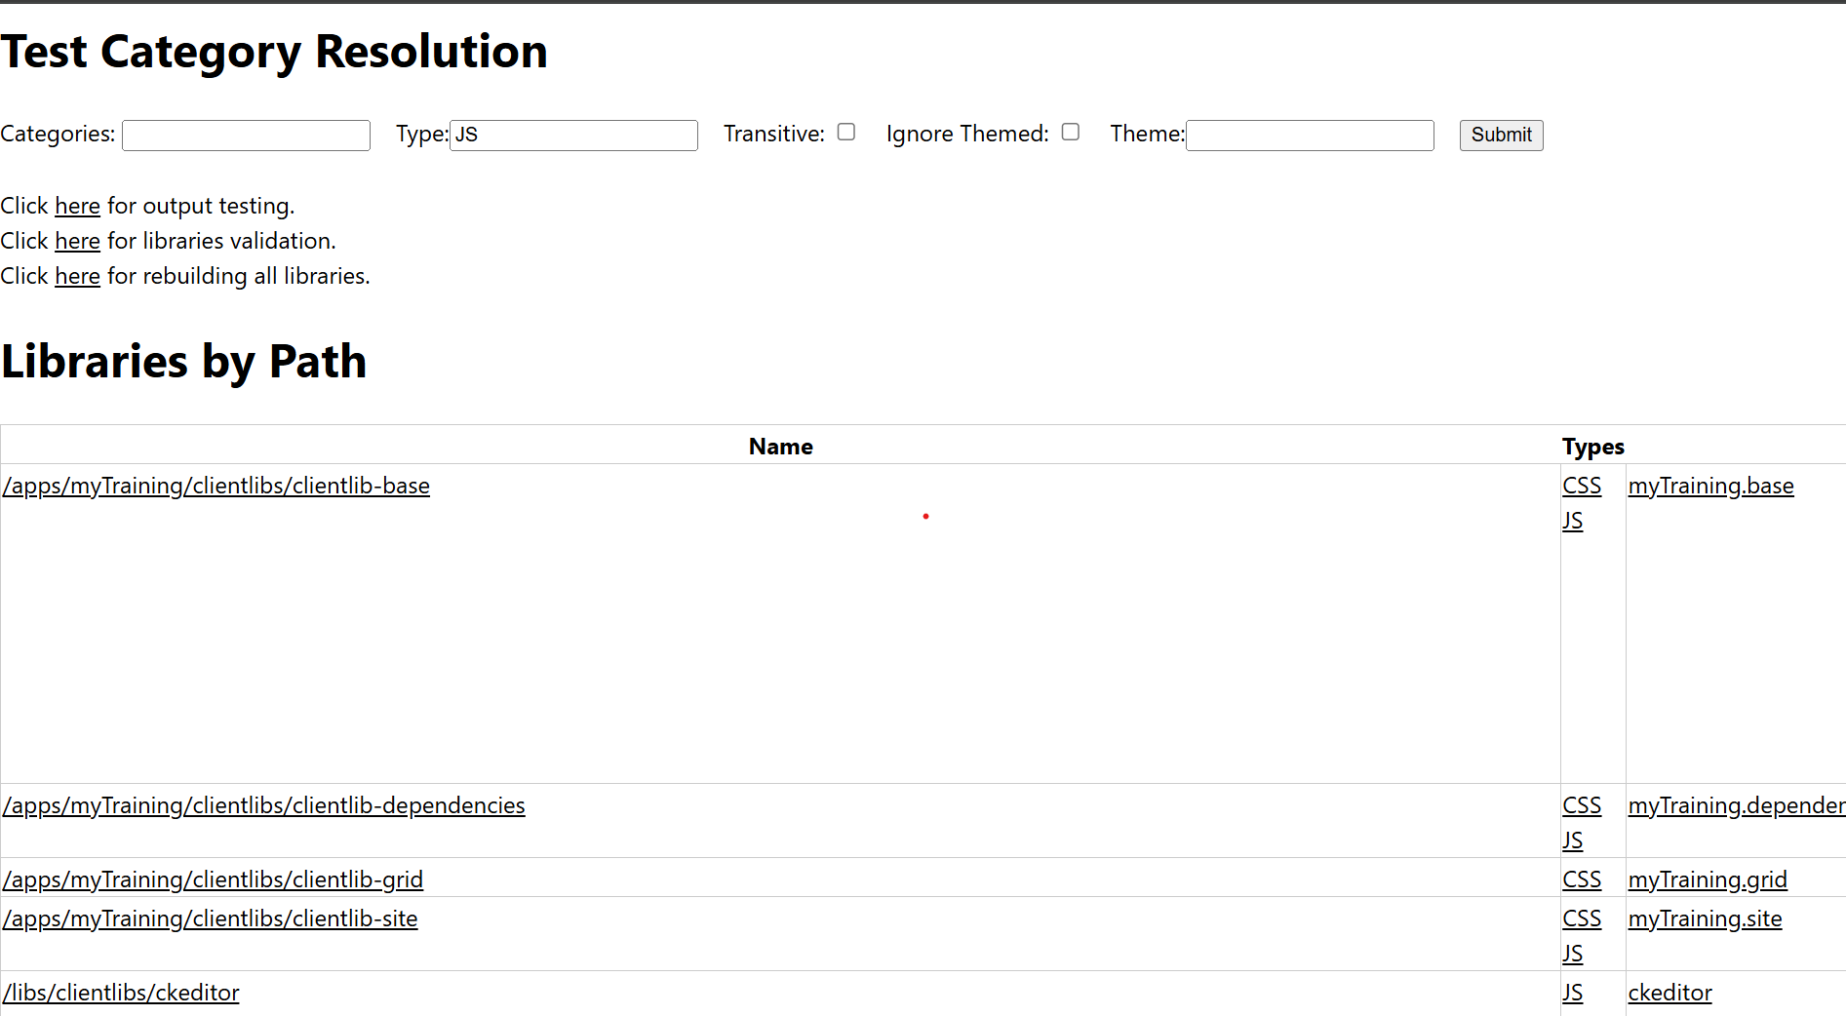

**18.Explain how client libraries are structured in AEM.**

Ans-ui.apps/src/main/content/jcr_root/apps/myTraining/clientlibs

